HR DATA

1. Employee Count:

SELECT

COUNT(employee_count) AS Employee_Count

FROM

hrdata;



1. Attrition Count:

SELECT

COUNT(attrition) AS Attrition_Count

FROM

hrdata

WHERE

attrition = 'Yes';



1. Attrition Rate:

SELECT

ROUND((SELECT

COUNT(attrition)

FROM

hrdata

WHERE

attrition = 'Yes') * 100 / (SELECT

COUNT(employee_count)

FROM

hrdata),

2) AS attrition count

;

1. Active Employee

SELECT

( COUNT(employee_count)

- (SELECT

COUNT(attrition)

FROM

hrdata

WHERE

attrition = 'Yes'))

FROM

hrdata AS Active_emp;

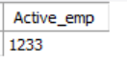

1. Average Age

SELECT

ROUND(AVG(age), 0) as Average_Age

FROM

hrdata;

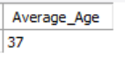

1. Gender by Attrition

SELECT

gender, COUNT(attrition) AS Attrition_Rate

FROM

hrdata

WHERE

attrition = 'Yes'

GROUP BY gender

ORDER BY Attrition_Rate DESC;

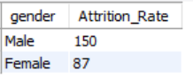

1. Department wise Attrition:

SELECT

department,

COUNT(attrition) AS Attrition_Rate,

ROUND((SELECT

COUNT(attrition) / (SELECT

COUNT(attrition)

FROM

hrdata

WHERE

attrition = 'Yes') * 100

),

2) AS Percentage

FROM

hrdata

WHERE

attrition = 'Yes'

GROUP BY department

ORDER BY Attrition_Rate DESC;

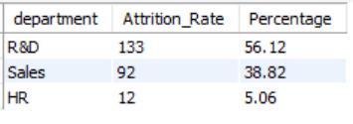

1. Employee Count by age and gender:

SELECT

age_band, gender, COUNT(employee_count) AS Total_count

FROM

hrdata

GROUP BY age_band , gender

ORDER BY age_band;

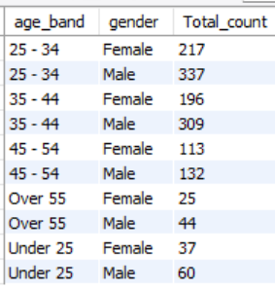

1. Education field by Attrition:

SELECT

education_field, COUNT(attrition)

FROM

hrdata

WHERE

attrition = 'Yes'

GROUP BY education_field;

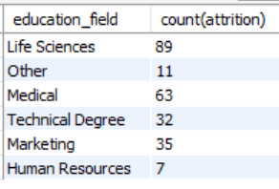

1. Attrition Rate by Gender for different Age Groups:

SELECT

gender,

age_band,

COUNT(attrition) AS Count,

ROUND((COUNT(attrition) * 100) / (SELECT

COUNT(attrition)

FROM

hrdata

WHERE

attrition = 'Yes'),

2) AS Percentage

FROM

hrdata

WHERE

attrition = 'Yes'

GROUP BY age_band , gender

ORDER BY age_band;

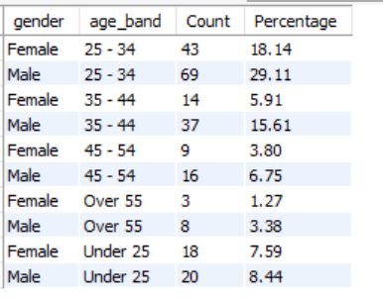

1. Job Satisfaction Rating

SELECT

job_role,

SUM(CASE

WHEN job_Satisfaction = 1 THEN employee_count

ELSE 0

END) AS one,

SUM(CASE

WHEN job_Satisfaction = 2 THEN employee_count

ELSE 0

END) AS two,

SUM(CASE

WHEN job_Satisfaction = 3 THEN employee_count

ELSE 0

END) AS three,

SUM(CASE

WHEN job_Satisfaction = 4 THEN employee_count

ELSE 0

END) AS four

FROM

hrdata

GROUP BY job_role

